CIS40A Lab 2: Making Network Cable
In this lab, we will prepare Unshielded Twisted Pair (UTP) Ethernet cable, CAT5E and Coaxial. Refer to the following steps and use the equipment provided in PSC-16 at MVC campus.

Part A: Making Ethernet Cable (UTP)
What you'll need:
- Unshielded twisted pair (UTP) patch cable
- Modular connector (8P8C plug, aka RJ45)
- Crimping tool
- Cable tester
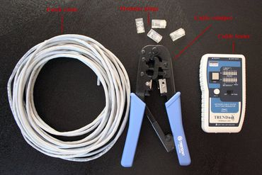Ed Rhee
There are four pairs of wires in an Ethernet cable, and an Ethernet connector (8P8C) has eight pin slots. Each pin is identified by a number, starting from left to right, with the clip facing away from you.
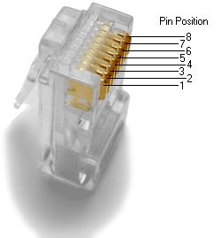
The two standards for wiring Ethernet cables are T568A and T568B. T568B is the most common and is what we'll be using for our straight Ethernet cable. The tables below show the proper orientation of the colored wires to the pins.
T568A Standard
Pin 1 | White/Green
Pin 2 | Green
Pin 3 | White/Orange
Pin 4 | Blue
Pin 5 | White/Blue
Pin 6 | Orange
Pin 7 | White/Brown
Pin 8 | Brown

T568B Standard
Pin 1 | White/Orange
Pin 2 | Orange
Pin 3 | White/Green
Pin 4 | Blue
Pin 5 | White/Blue
Pin 6 | Green
Pin 7 | White/Brown
Pin 8 | Brown

Step 1: Strip the cable jacket about 1.5 inch down from the end.
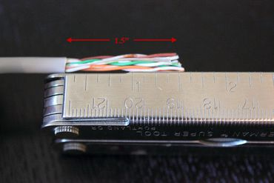Ed Rhee
Step 2: Spread the four pairs of twisted wire apart. For Cat 5e, you can use the pull string to strip the jacket farther down if you need to, then cut the pull string. Cat 6 cables have a spine that will also need to be cut.
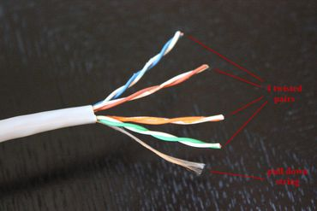
Step 3: Untwist the wire pairs and neatly align them in the T568B orientation. Be sure not to untwist them any farther down the cable than where the jacket begins; we want to leave as much of the cable twisted as possible.
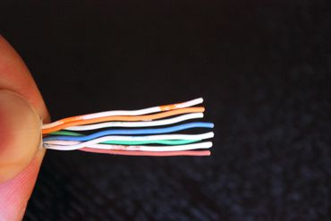
Step 4: Cut the wires as straight as possible, about 0.5 inch above the end of the jacket.
Step 5: Carefully insert the wires all the way into the modular connector, making sure that each wire passes through the appropriate guides inside the connector.
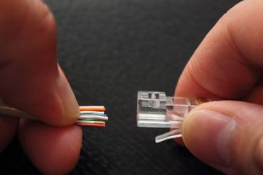
Step 6: Push the connector inside the crimping tool and squeeze the crimper all the way down.
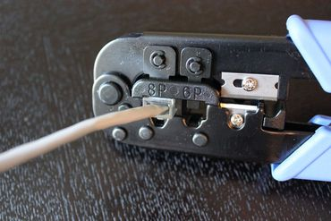
Step 7: Repeat steps 1-6 for the other end of the cable.
Step 8: To make sure you've successfully terminated each end of the cable, use a cable tester to test each pin.

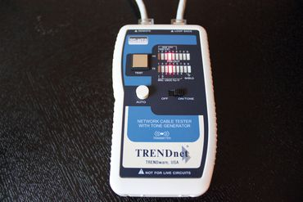
When you're all done, the connectors should look like this:
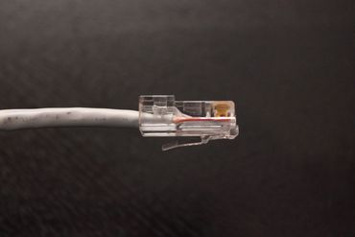

Step 9: If time permits, prepare a crossover cables, simply make one end of the cable a T568A and the other end a T568B.
Step 10: Take a picture, using your smartphone, of the successfully tested cable.
Step 11: Login Canvas and upload the picture of the successful cable.

Part B: Making a Coaxial Cable
Also see: https://youtu.be/2SbbWHH9ek0

Materials
You will need the following materials:
- Coaxial cable, at least 2 feet.
- Metal brush
- 2 F connectors (RG-6)
- Tools: Cable cutter, trimmer, and crimper

Instructions:

- Gather your materials. In order to terminate a coaxial cable, you will need the following tools and materials:
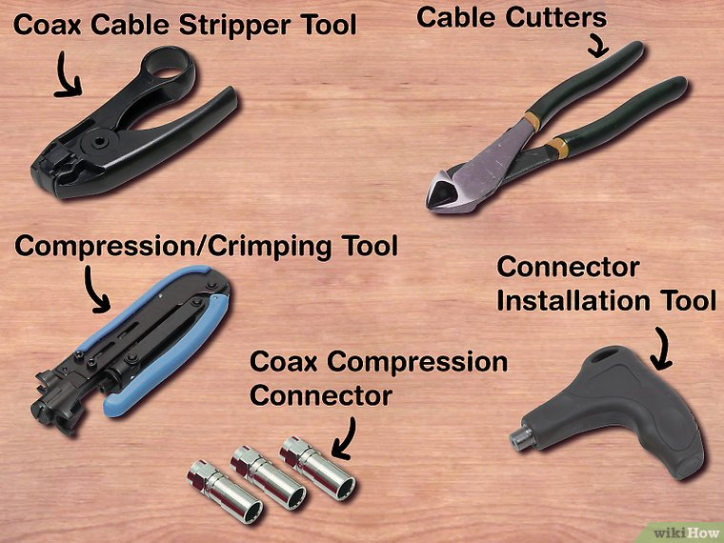

- Make a straight cut at the end of the cable. Use your cutting tool to make a straight cut at the end of the cable. After cutting, use your fingers to form the end of a cable back into a circle.
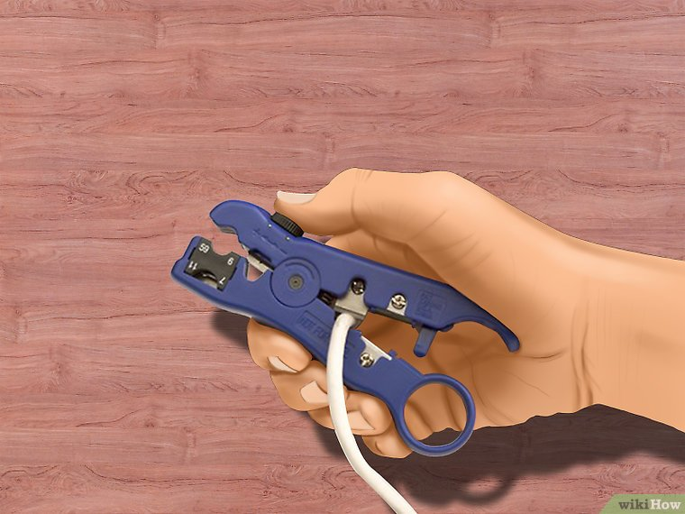

- Adjust your stripper to work with your cable. Most coaxial strippers can be adjusted to strip dual-shielded or quad-shielded coaxial cables. Use the included Allen wrench to adjust the stripper. If you don't adjust the stripper properly, you may strip the ground wire, damaging the cable.
  - The most common cable is RG-6, either quad- or dual-shielded. Make sure that the stripper is configured for RG-6 coaxial cable, and not another cable size such as Ethernet cable.
  - If your stripper is set to dual-shielding, but you try to strip a quad-shielded cable, not all of the shielding will be removed.
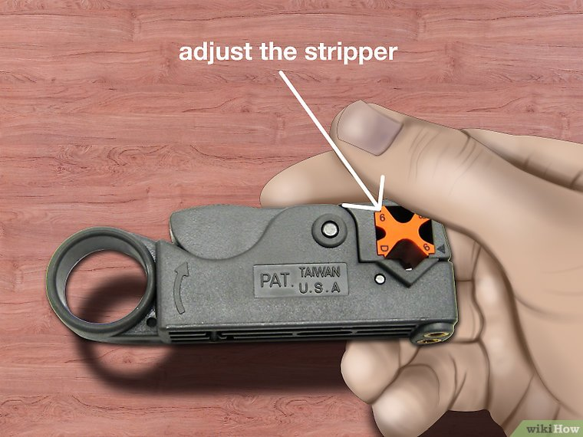

- Strip the end of the coax cable. Place the end of the coax cable into the stripper so that the end of the cable is flush with the far end of the stripper. Clamp the stripper down on the cable and spin it around the cable two to three times.
  - You can tell when the stripper is finished when you don't feel resistance anymore when spinning.
  - Don't pull the stripper off when finished. Unlatch it and open it to remove the cable.
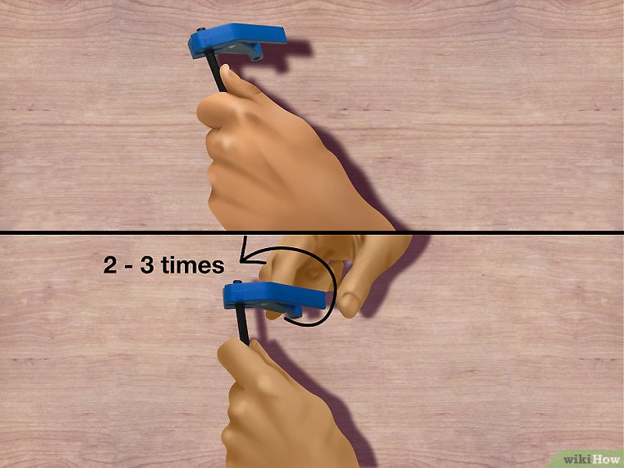

- Pull off the outer shield. After stripping the cable, you should see two segment cuts. Pull the outermost segment off of the cable. This should reveal the center conductor wire.

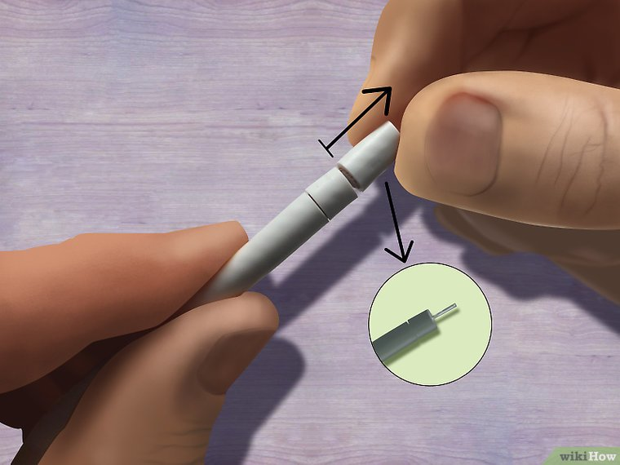

- Pull off the second segment. This will reveal the foil that insulates the cable. Find the edge of the foil and peel it off the cable. This should leave a single layer of foil around the white insulation.

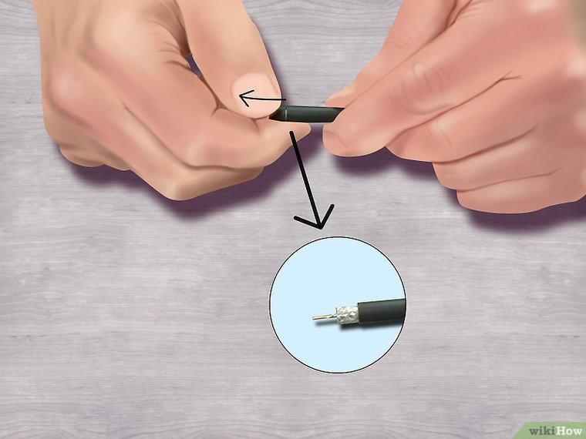

- Fold back the braid. When you pull off the cable jacket, you will see a lot of loose ground wires. Fold these back against the cable so that the connector will be touching all of the wires when installed. None of the wires should be blocking the white insulation.
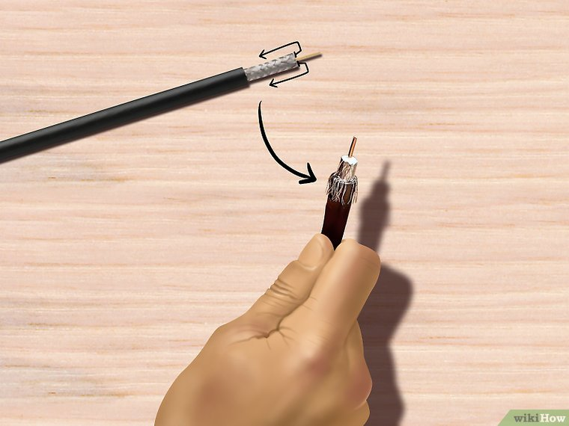

- Cut the conductor wire (if necessary). Most cable stripper tools will leave the correct length of conductor wire exposed, but it doesn't hurt to double check before proceeding. The exposed connector cable should be 3.9 mm (.156 inches) in length.
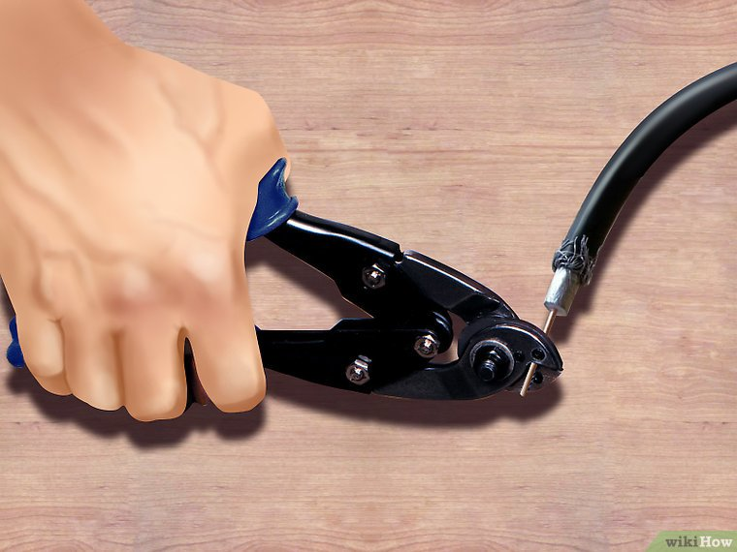

Put the connector onto the stripped end of the cable. Use a pusher tool to firmly push the connector onto the cable until the white insulation is flush with the connector.
  - Make sure you avoid bending the bare conductor wire when installing the connector.
  - You may need to twist the cable while pushing with the tool to get it firmly connected.

- Compress or crimp the connector. The process for compressing or crimping the connector varies depending on the type of connector you are using. Some require you to press down on the cable-end of the connector piece, while others require you to push the front and end of the connector piece into each other.
  - Squeeze the compression or crimping tool firmly. Most tools won't allow you to over-compress, but some can cause damage to the cable and connector if compressed too much.
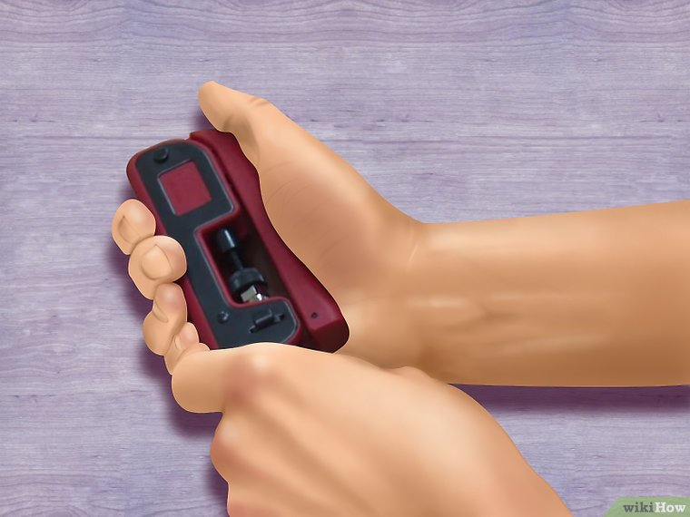

- Inspect the connection for imperfections. After you have finished compressing the connector, inspect it for any stray wires or loose connections. These can lead to a bad signal or nonfunctional cable.

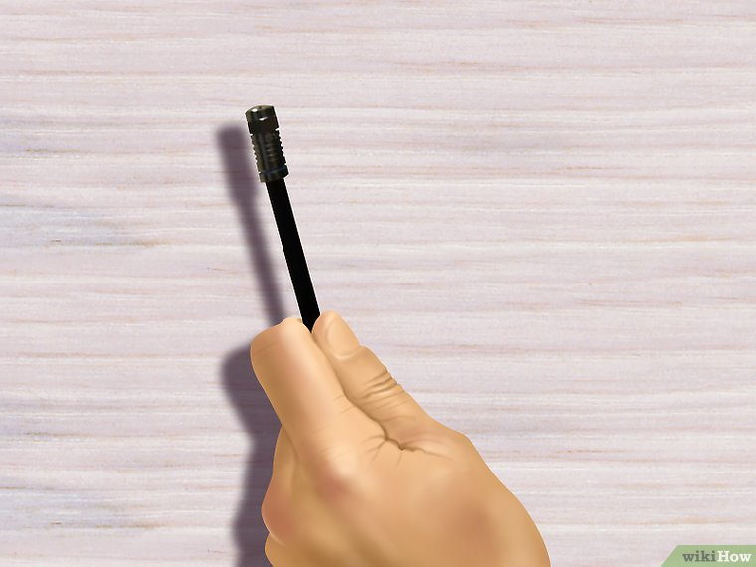
- Use your smartphone or webcam to take a picture of a tested cable for lab submission.
Login Canvas to submit lab: Part A and Part B cable images.

